

**American International University- Bangladesh**

**CSC 2209: Object Oriented Programming 1 (JAVA)**

**CO1 Evaluation**

**Project Summary Report**

**Summer 18-19**

**Group No: 24**

**Project Title: Electronic Toll Collection**

|  |  |
| --- | --- |
| Student Name | Student Id |
| RAHMAN, SHOJIBUR | **18-36205-1** |
| SAKUR, ABDUS | **18-37655-1** |
| SWOPNO, AHMED ALIF | **18-37750-1** |
|  |  |

**Introduction:**

The electronic toll collection system will work as a prepaid toll payment system which will save a lot of time since vehicles passing through the toll plaza won’t have to stop to pay the toll anymore. Our country's toll collection system, is one of the sole reasons for the traffic jam on highways and we hope to offer a solution for this problem via this project.

**User Category:**

There are two types of Users here. They are:

* Admin
* Client (Toll payer)

**Feature List:**

In this project the “Admin” has the following features:

* Introducing different toll packages
* Managing those toll packages
* Checking reports of all toll transactions
* Checking existing user lists

In this project the “User Type 2” has the following features:

* Profile Creation
* Adding unlimited vehicles
* Managing existing vehicles
* Checking self-transaction history
* Checking all available toll places and their fares
* Paying the toll before crossing the gate

**Database Table Description:**

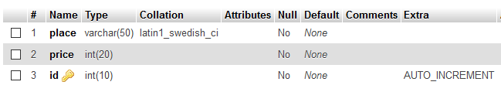

**Fig: Toll Table**

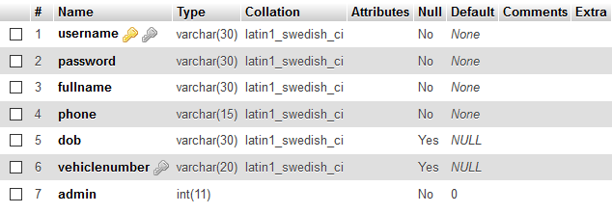

**Fig: Client Table**

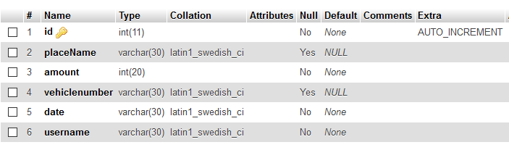

**Fig: Transaction Table**

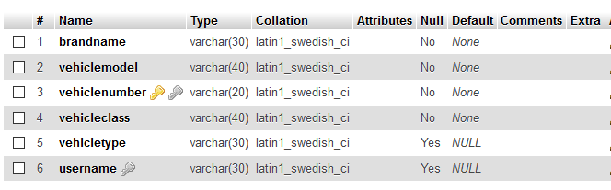

**Fig: Vehicle Table**

**OOP and Java Concepts Used:**

* Encapsulation: It is a process of wrapping code and data together into a single unit
* Inheritance: It is a mechanism in which one object acquires all the properties and behaviors of a parent object.
* Polymorphism: It is the ability of an object to take on many forms. The most common use of polymorphism in OOP occurs when a parent class reference is used to refer to a child class object.

**Class Diagram:**

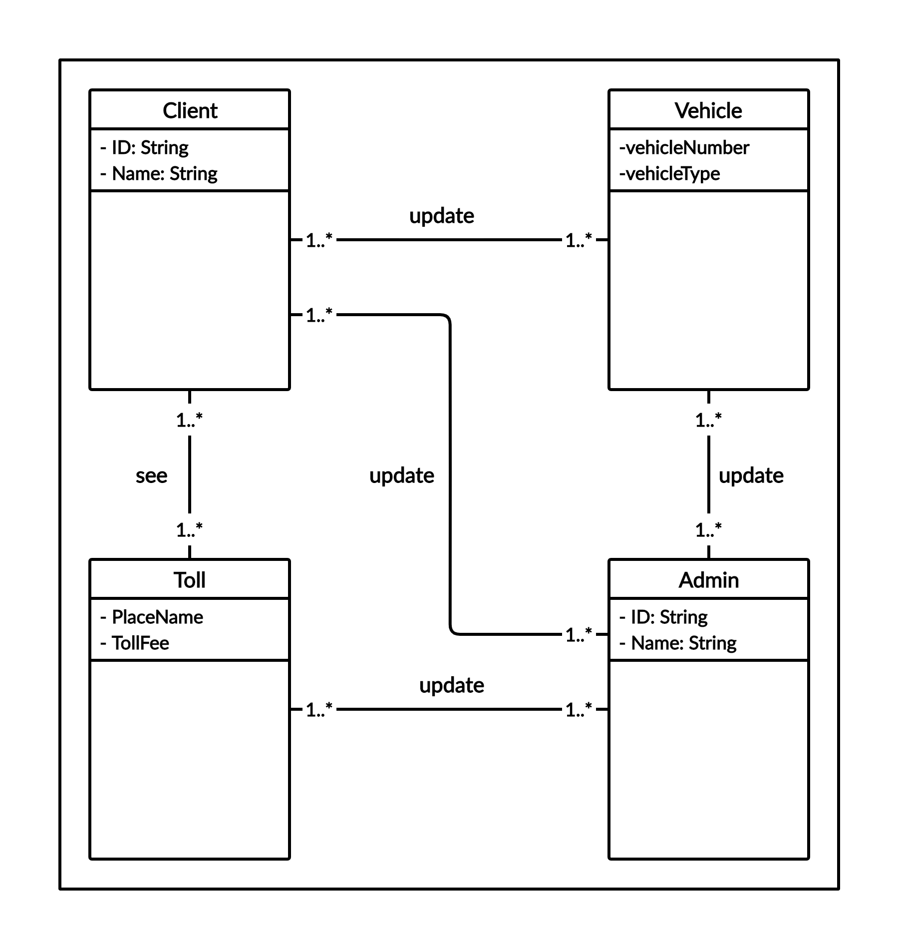

**Tools Used:**

To develop this project we have used the following:

* Sublime Text/ Notepad++
* Dia
* Adobe Photoshop

**GUI Description:**

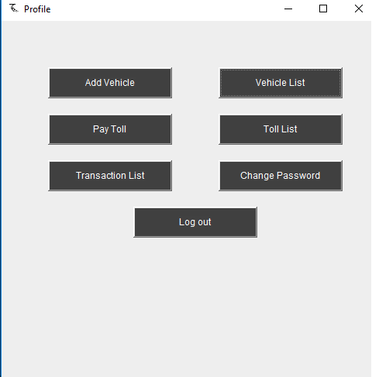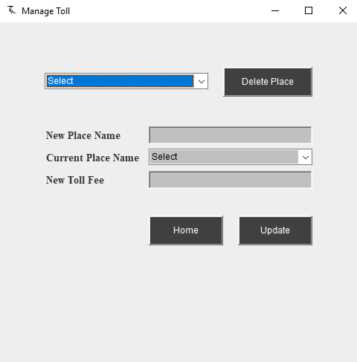

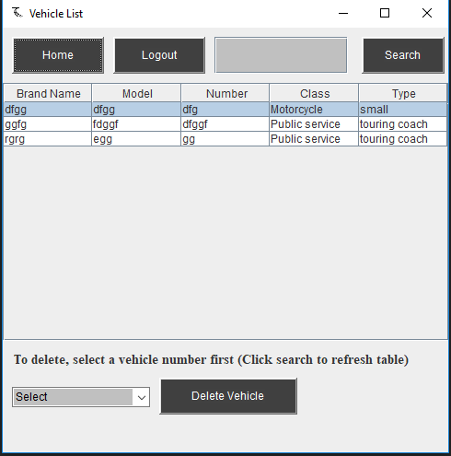

**Fig: Client Dashboard Fig: Manage Toll Places and Fares (Admin)**

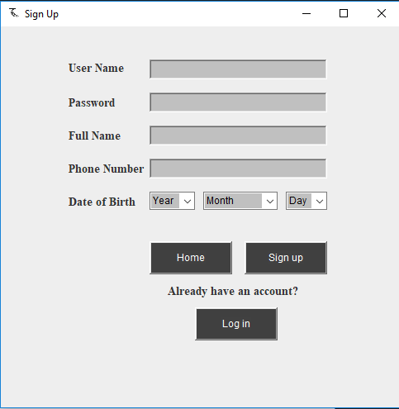**Fig: Vehicle list & manage vehicle (Client) Fig: Sign Up page**

**Client Dashboard:**

This is the landing page for client type accounts. User can navigate through all the available options (pages) from here and get back from inner pages as well if necessary.

**Manage Toll:**

Admin type users can edit or update information for already added toll places and fares. They can delete toll place entries as well from here. All the available toll places are shown in the dropdown

**Vehicle List:**

Client type users can see the list of vehicles they added and all related information as well. They can sort the table by clicking on header cells and then if necessary can use the bottom dropdown to delete a specific entry

**Sign Up Screen:**

This is the Sign Up page for all the Client type users. Here the DOB part is developed to be an interactive set of fields it generate dates based on users selection, for example February can only have up to 28th or in case leap year 29th, April can’t be 31 etc. The cell number should also be a BD number which is validated using regular expression. All the forms within the system has individual validation for each individual necessary field/s.

**Impact of this Project:**

This project if marketed and introduced will significantly reduce traffic congestion on toll gates which will improve our day to day life dramatically on highway roads. Just on this recent Eid people had to be on road for more than 24 hours where it take only 4-5 hours to reach the distance without traffic and in almost all cases toll gate congestion had a huge effect on this huge jam. A similar project could improve the situation drastically.

**Limitations and Possible Future Improvements:**

Possible integration with real Payment Gateway, vehicle and personal information verification, email/sms notification etc.